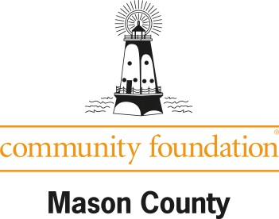

Resources for Nonprofit Fundholders
Sample Short Messages
People often need to hear or see a message seven times before they act. Using these simple messages throughout your communications can be a consistent reminder to your donors. Place them on letterhead, as a “PS” in letters or emails, in your newsletter, on your website, as social media posts, on your gift envelopes, in your email signature, etc.
- A gift to the [organization]’s endowment fund is an investment in the future.
- Anyone can leave a legacy gift! Simply name XYZ’s Endowment Fund as a beneficiary of your savings, checking, or retirement account.
- Remember, you can provide for [organization]’s future with a gift in your will.
- Help us build our future – give to our endowment fund at mason-foundation.org.
- You’ve made an impact through your giving. A gift to our endowment fund at the Community Foundation for Mason County today or through your estate will ensure your support…forever.
- Is it time to update your will or trust? Please consider designating a gift to the [organization’s] endowment fund at the Community Foundation.
- Do you have a retirement account or life insurance policy? If so, you can name [our organization/fund] as a beneficiary of it and continue your support of our work after you’re gone. Ask your plan administrator or agent for the form to make this simple, no-cost change.
- If you’ve named [our organization/fund] in your will or as a future beneficiary, please let us know. We want to thank you!
- Remembering the [organization/fund] in your estate plan means there will always be [meals for kids/hospice care/music/clean water, etc.]. Learn more about your giving options by contacting [name].
- Make a lasting contribution toward a better [neighborhood/community/education/environment]. Contact [name] to learn how you can leave a legacy.
- Your love for [your organization/community/school/church] can live on through a gift to the [organization]’s endowment fund.
- While 70% of us give charitably during our lifetimes, only 10% leave a gift through our estates. We can do better! Leave a gift to our endowment fund at the Community Foundation for Mason County.
- Love [organization] – Leave 5%!
- Did you know we’re planning for our future? Help us by giving an extra gift to boost our endowment fund at the CFMC.
- [sample short story message] Muskegon Public Schools teacher Shirley Fett left a six-figure gift to the Big Red Education Fund through her will, meaning each year more teachers have the classroom “extras” that can make such a difference in students’ lives. Have you thought about what a gift from your estate would allow our organization to do in the future?
- Because of [Edith Anderson’s] estate gift, [hospice care] is available to more people. What will your legacy be?

